ECHO MISP TRAINING REPORT ON
Minimum Initial Service Package (MISP)
For
Reproductive Health in Crises Situation
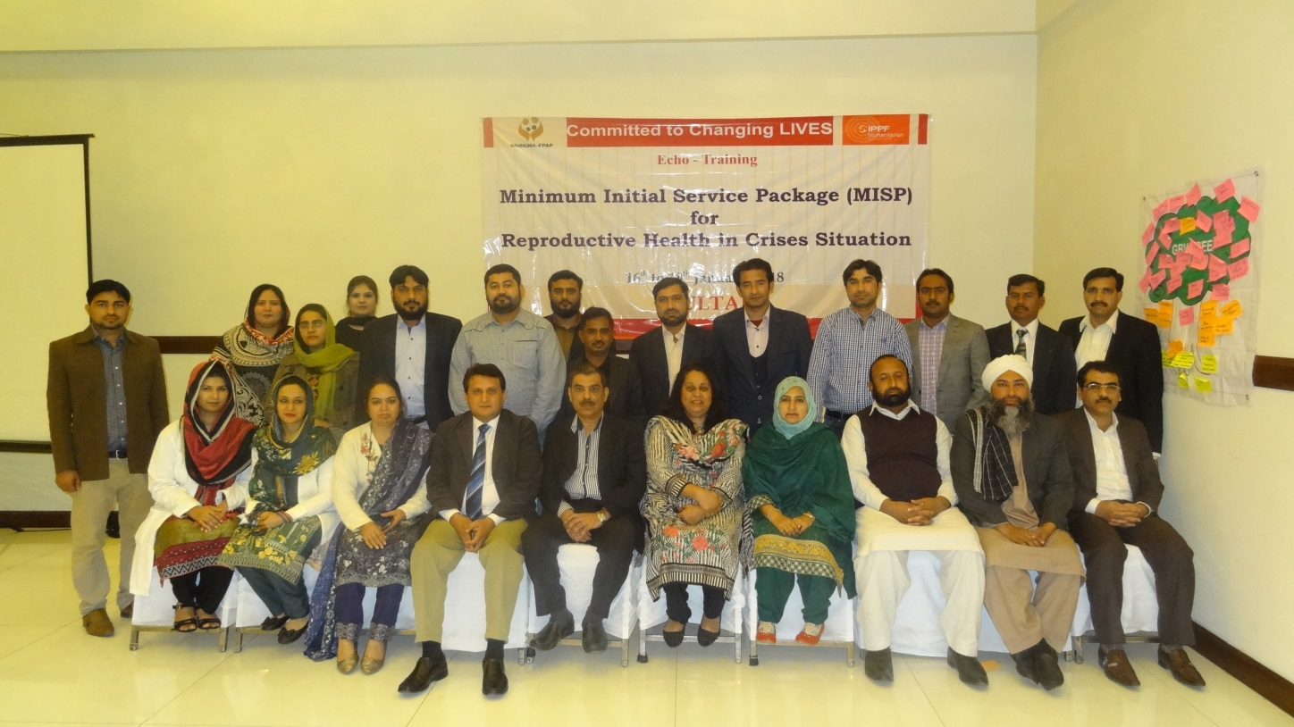

16 to 18 January, 2018

Ramada Hotel, Multan

Organized by:

Rahnuma-Family Planning Association of Pakistan
Committed to Changing LIVES
Committed to Changing LIVES
Committed to Changing LIVES
NFPA

Table of Contents
3
Learning outcomes of the Training: 4
Steps towards Resilience 8
Affects flood 2010 9
Women and War – Video Clip 9
Module 1: Sexual and Reproductive Health in Crises Setting. By Dr. Anjum 10
Coordination Mechanisms of SRH in Crises 11
Structure, Response, and Lesson learned 12
Lesson Learnt from Previous disasters 12
Group work: 13
Exercise Protocols for responding to Survivor 14
Module 4: Maternal and Newborn Health 16
Module 5: Summary and Logistics: by Dr. Nadeem 16
Closing Ceremony 17
Comparison of Pre and post test result 19

Committed to Changing LIVES
Committed to Changing LIVES
Committed to Changing LIVES
Background

Pakistan is a disaster prone country and has experienced various types of disasters over the years, affecting sustainability of its development initiatives and impacting on the stability of its national economy. During the past six decades Pakistan has experienced more than 22 flood events, out of which more than half occurred within the last two decades. Besides this, Pakistan is also prone to earth quakes.

Whenever there is a crisis the effected population lacks access to health services. Limited access to health service in turn has a disproportionate effect on women and children, especially in crisis situation. In fact Sexual and Reproductive Health (SRH) is a significant public health need in all communities in all situations and is amplified in crisis situation.

To effectively confront the challenges, the most crucial tasks remain to strengthen the health system, government’s capacity, and cope with humanitarian crises and to priorities the activities required. These services need to be focused on and strengthened in preparation to prevent and to reduce SRH-related morbidity and mortality during emergencies. Training is an important component of preparedness phase. Recognizing the concerns Rahnuma-FPAP organized this training for Stakeholders to build and enhance capacities in provision of Reproductive health services in crisis.
This report therefore provides information about the three-day workshop and highlights lessons learnt and the way forward for implementation of MISP.

SUMMARY

Location: Ramada Hotel, Multan

Number of participants: 27

Target (profile of participants): The target audiences were representing Health Department of Govt. of Pujab, Population Department and R-FPAP Staff. The participants were representing different districts of Multan.

Facilitators: A team of Master trainers facilitated the workshop.
Dr Anjum Rizvi, Director Programs, R-FPAP

Dr Nadeem Mahmood, Project Director R-FPAP

Guests:

- Mr. Barak Ullah Khan
Additional Deputy Commissioner,
Multan

- Mr. Zeshan Nasir
District Population Welfare Officer,
Multan.

The objective of this training was to enhance the capacity and establish a pool of resources at national levels with awareness, knowledge and understanding of the MISP. Thereby, this process will augment the capacity to better coordinate the implementation of MISP at national levels.

Learning outcomes of the Training:

Upon completion of the Training, participants should be able to:

Advocate for SRH and SGBV issues in crises

Apply core concepts and techniques provided in the MISP Apply coordination skills for the implementation of the MISP
Produce an action plan to integrate SRH and GBV into national emergency preparedness plans

The training process was interactive and participatory using both English and Urdu for two way communication. Group work was undertaken for the sessions as per the training manual and active participation by all was ensured. Time management was strictly observed. A mix of methods was used for the training. They are as follows:

- Brainstorming
- Role play
- Participant observation
- Case study, group work and group presentation
- Question and answers
- Visual aids
- Practical Experiences

- Power point presentation
- Energizers

The Module covered during the training session were:-

- SRH and Coordination Mechanisms in Crises

- Sexual Violence and Gender-Based Violence in Crises

- HIV and STIs in Crises

- Maternal and Newborn Health in Crises

- Summary and Logistics

DAY I

The training started with registration of participants followed by the inaugural session, introduction of participants, expectations from training and pretest.

Inaugural session

Inaugural session started with Recitation of Holy Quran followed by welcome address.

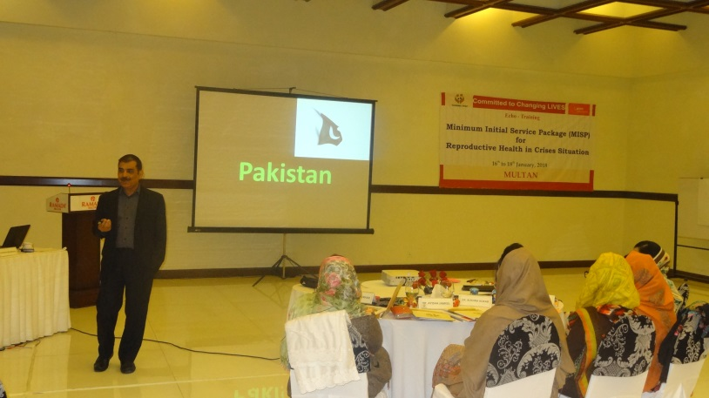
Dr. Nadeem Mahmood welcomed all the guest and participants. A detailed overview of the IPPF and SPRINT trainings was delivered and further the participants were briefed regarding the aim and objectives of MISP in crisis.

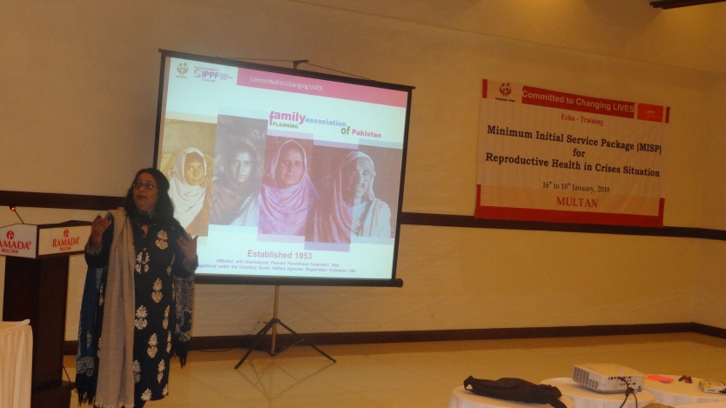
Dr. Anjum Rizvi gave a brief introduction about the history and background of The Rahnuma-Family Planning Association of Pakistan. She emphasized the importance of maternal health in crisis situation.

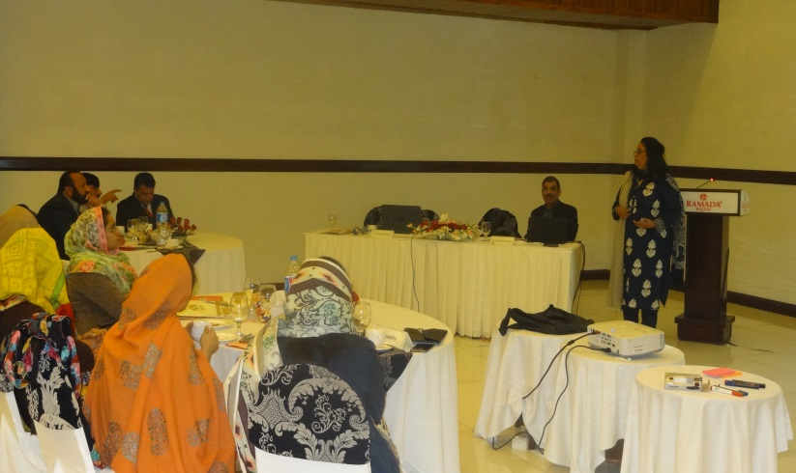
Dr Anjum Rizvi highlighted the vision and mission of Rahnuma-Family Planning Association of Pakistan. She further explained in detail the thematic and geographical areas of the organization .It was also mentioned that Advocacy, Services delivery and Technical support are core areas of Rahnuma - FPAP works with special focus on marginalized and vulnerable sections of society.
Introduction of Participants

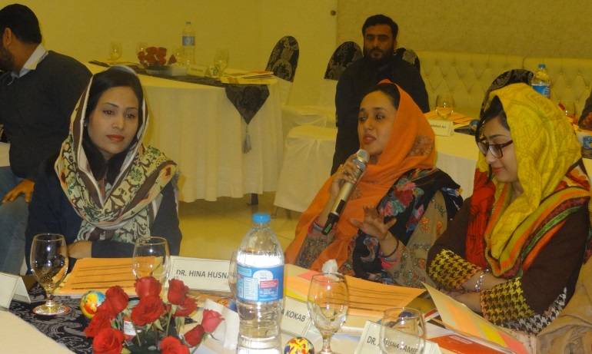
Introduction of participants was completed in an interactive way.

They were asked to write their expectations and fears regarding the training on colored cards.
Expectations were as following:

- We expect to learn skills to be a good trainer.

- Gender based Violence shall be learnt at length

- Training would be participatory and interactive. Will get detailed knowledge on MISP

- Get information on SRH in crisis
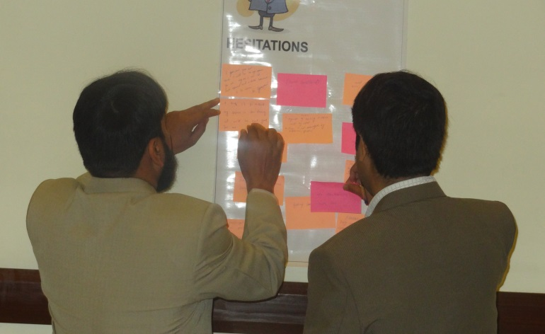
Fears were as follows:
- Worried about getting optimum benefits from the training

- Doubtful about discussing sexual violence openly since sexual violence is a sensitive topic
- Topic is lengthy and time is less Afraid of pre-test

Norms Setting

Norms setting was carried out in participatory manner: main points are as below

  - Cell phone on silent mode
  - No cross table talks
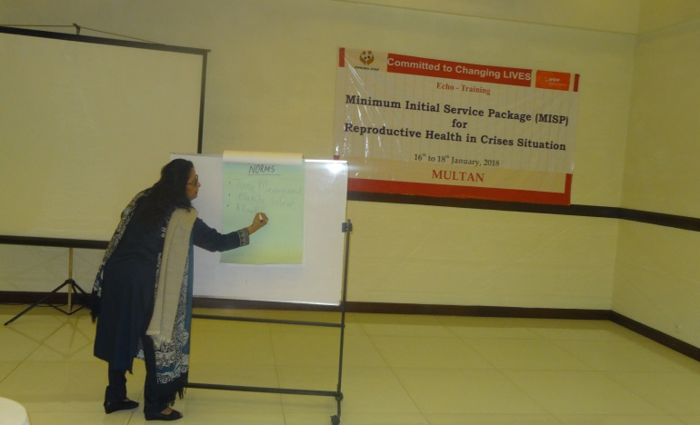
  - Speak loudly
  - Hand raising
Observe punctuality

  - Respect other’s opinion
  - No discussion on religion

  - Don’t breach the confidentiality of the training
  - Sessions should be interactive and participatory

MISP Pretest:

An assessment prior to the training was conducted to know the basic level understanding of the participants. Questionnaires were circulated. Participants were instructed to report their answers on the sheet without putting their names on it. A detailed analysis was made after going through the pre-test answer sheets. The participants were informed that a post-test would be done at the end of the training for the evaluation purpose.

Disaster – Country Scenario

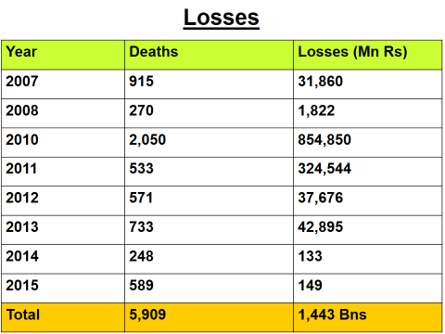
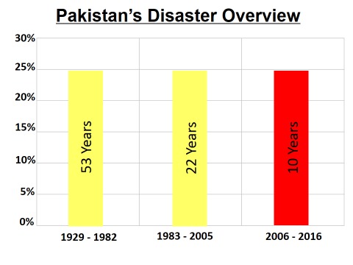
The facilitator (Dr. Nadeem) explained that due to certain geographical conditions, climatic change, and high degrees of exposure and vulnerability, Pakistan is a disaster-prone country. A range of hydrometeorological, geophysical and biological hazards including avalanches, cyclones, and storms, droughts, floods, glacial lake outburst floods (GLOF), earthquakes, landslides, tsunamis and epidemic pose risks to Pakistani society. Some of these hazards (e.g. floods, landslides etc.) are predominantly seasonal and occur on an annual basis, whereas other hazards such as earthquakes and tsunamis are rare events but potentially highly destructive in nature. In addition to natural hazards, a variety of human-induced hazards threatens Pakistani society, economy, and environment. They include industrial and transport accidents including oil spills, nuclear hazards, urban and forest fires as well as civil unrest.

Steps towards Resilience
- National Disaster Risk Management Framework - 2007
- Establishment of NIDM
- National DRR checklist
- National Climate Change Policy - 2012
- National Disaster Management Plan (NDMP) - 2012
- National DRR Policy - 2013
- National Policy Guidelines on Vulnerable group
- Gender Mapping
- National Disaster Risk Management Framework – 2007
- National Land-use Planning
- National Building Code Policy
- National Fire Policy
- National Response and Recovery Frameworks

Affects flood 2010
- Districts - 78 / 141
- Population - 20 m
- Deaths - 1985
- Injured - 2946
- Area - 100,000 Sq Km
- Cropped area - 2.03 m hec (21%)
- Houses - 1.6 m

Women at War – Video Clip

The video clip depicted the plight of women and girls in war being most vulnerable to sexual violence. The chaos of the crisis brings a sense of insecurity among the most vulnerable, many of those are unable to access supplies and in some cases they are at high risk of violence. For their survival, they need food, water, shelter, protection and healthcare. During war and in refugee setting women won’t stop getting pregnant. Besides, violence they are at risk of HIV/AIDS also. The video ended up with a key message that “Reproductive Health is not luxury but a human right – it saves life”. Participants were asked to comment on messages. The comments are as below:

- Being vulnerable women are more at risk.

- More attention is needed towards women health in crisis situation

- Support to women and children is of utmost significance

Module 1: Sexual and Reproductive Health in Crises Setting. By Dr. Anjum

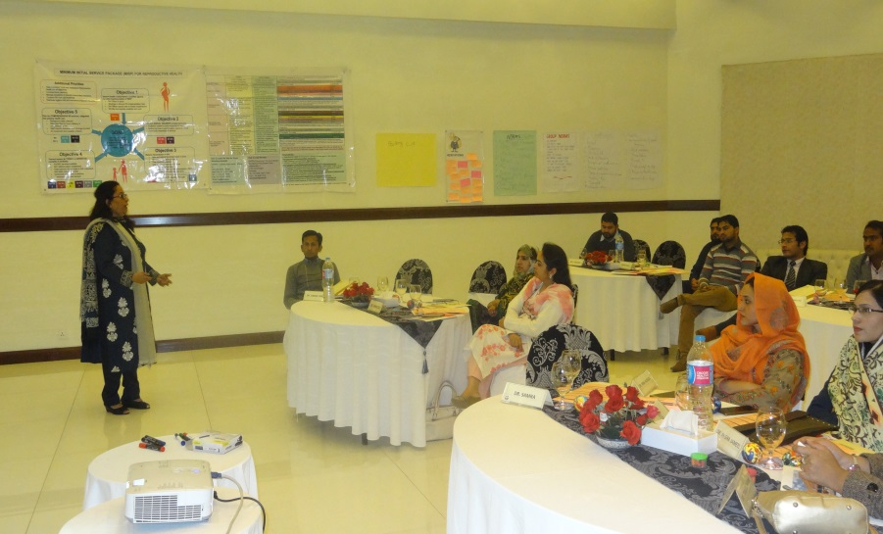
An overview of the SRH was taken into account with emphasis on Sprint initiative, definitions, terminologies and concepts for emergency management and response. The importance of MISP and its objectives and activities were discussed in detail. Its goal is to reduce the preventable sexual and reproductive health morbidity and mortality. The four step procedure involved in the SPRINT initiative were discussed in length. It is again a holistic approach that takes mitigation, preparedness, response and recovery into account. Participant took keen interest in session as it was interactive. They were asked about causes of crisis, type of people affected, and description of the SRH. It was further emphasized that access to sexual and reproductive health is a human right and Implementation of MISP in the acute emergency phase save lives, disease and disability among the people in crisis. Its goal is to reduce the preventable sexual and reproductive health morbidity and mortality. The four step procedure involved in the SPRINT initiative were discussed as a holistic approach that takes mitigation, preparedness, response and recovery into account.
Comments by Participants:

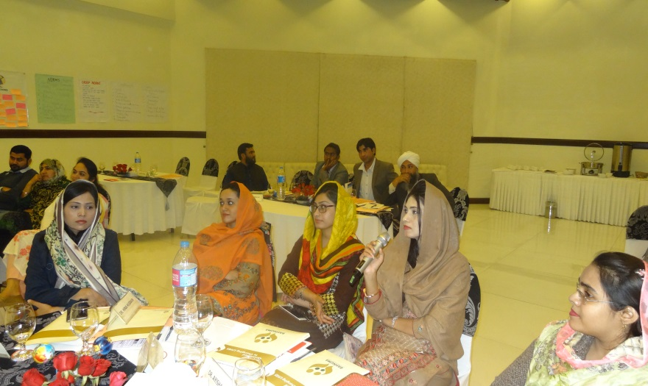
Participant found session quite interesting and interactive particularly the MISP objectives. They were asked to list causes of crisis, type of people affected, and description of the SRH. Almost all the participants responded to the queries. Gender based violence was a new and difficult topic for them to discuss but all of them agreed that GBV is never touched upon and should be addressed properly.

DAY II

Recap Day 1

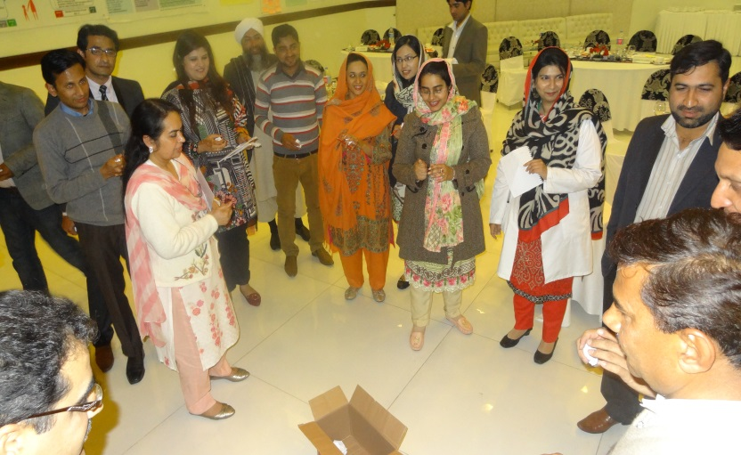
Review of day one was conducted by two participants covering MISP objectives and coordination. Dr. Nadeem Mahmood interacted with the participants and explained the day one topics

Coordination Mechanisms of SRH in Crises

Dr Nadeem has given detail on coordination mechanism. He delivered that coordination is an important component, specifically in crisis situation, among agencies, clusters, within health programming, SRH officer/working group etc. The global cluster formation to strengthen the coordination mechanism, National & Sub – national level crisis coordination mechanism was explained in detail. All steps of coordination were discussed with main focus on the appointment of SRH coordinator and his roles & responsibilities. It was further explained that coordination in crisis situation improves efficiency, effectiveness and speed of response and helps avoid gaps and duplication of services.
For Challenges
- Lack of information sharing to avoid duplicity
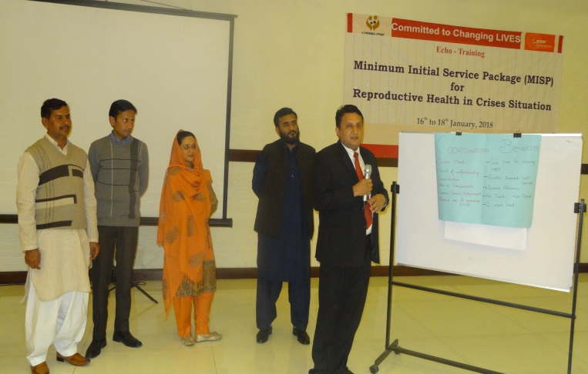
- Civil-Military relationship
- Donors outreach and awareness
- Federal Level
- Strategic group
- Operational group
- Provincial & Districts Level
- Coordination group
- Facilitation to relief workers
- Donors awareness and facilitation
- Security of relief workers
- Deployment of foreign civil and military assets

Structure, Response, and Lesson learned
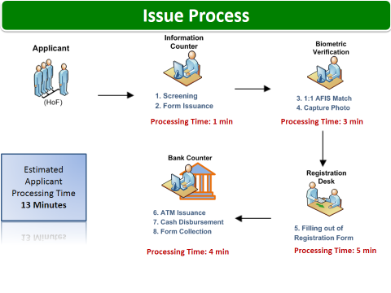
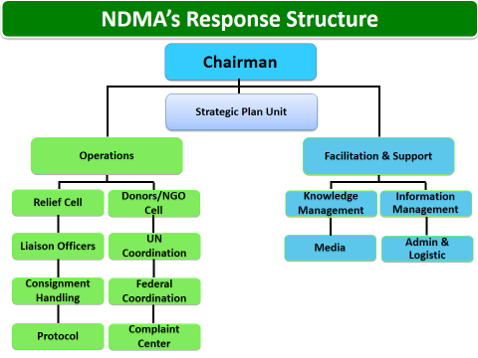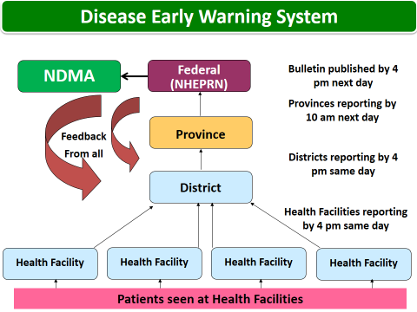

Lesson Learnt from Previous disasters
- Focus on DRR rather than response
- Elaborate planning
- Capacity of Provincial/District DMAs
- Gender Issues
- Coordination at micro level
- One window operation/facilitation
- Information sharing
- Civil-military coordination

Sexual and Gender Based Violence: Dr. Anjum

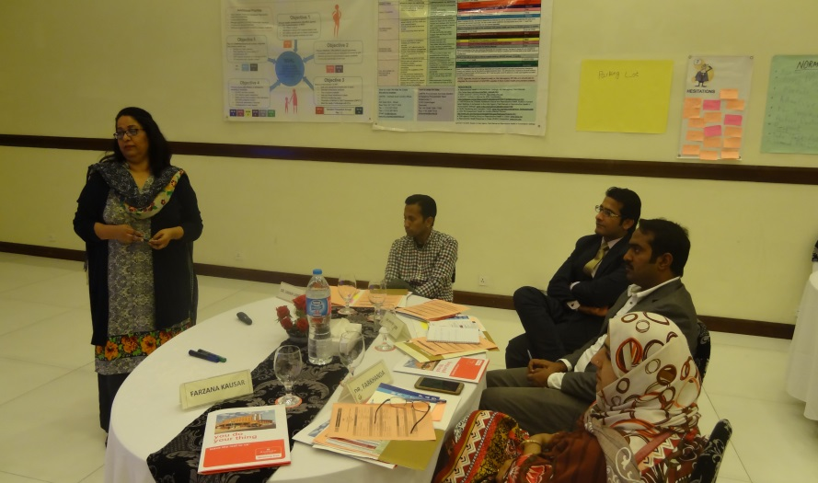
This topic is divided into two sections prevention and response in acute phase and as the situation allows. The definition and forms of the GBV were discussed in detail. Difference between sex and gender, Social and cultural expectations, roles and responsibilities of male and female etc were the main features of the session. GBV tree was discussed through group work making it interactive and participatory. They were asked to identify type, contributing factors and root causes of GBV. It was stressed that Gender-based violence is a cross-cutting issue that requires coordinated action by all sectors. Medical services required for survivor were discussed in detail followed by prevention. Standard Operating Procedures were discussed at length, which outlined the roles and responsibilities of the organizations while responding to sexual violence. Key points for setting up a clinic in response to case of sexual violence were discussed in detail.

Comments by Participants:

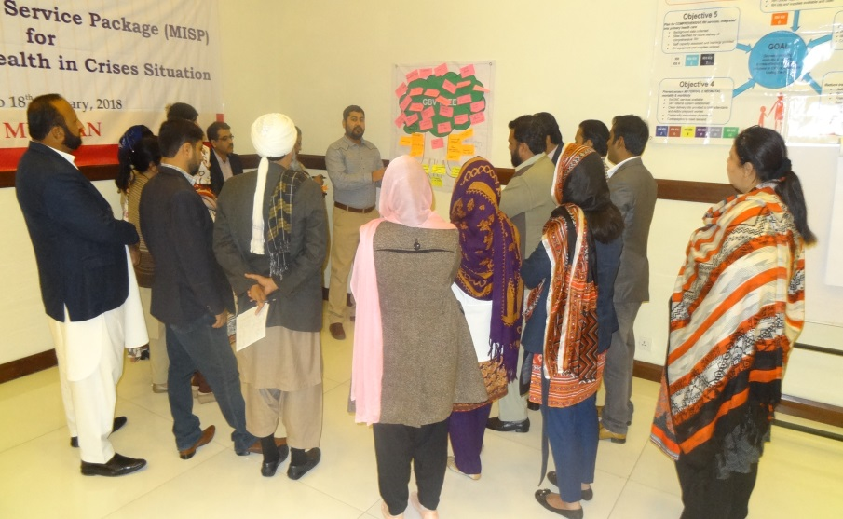
The session was quite interactive. Most participants were both unfamiliar and hesitant to discuss the subject but then some of them shared different experience/practices they encountered. Over all participants were of the view that this is an important but neglected topic and this session has clarified many queries. The participants shared their experience/practices in there settings. They also pointed out the reasons of the under reporting of the GBV cases in their society as fear of threat, associated stigma, shameful situation, unsatisfactory medical services, and Lack of trust.

Group work:

The participants were divided into three groups. One group was asked to write types of GBV, 2nd group identified the different factors of GBV and third group defined the root causes of creating GBV. After 15 minutes, the groups posted their cards on GBV tree and then one representative from each group presented their group work with discussion on the GBV tree.

Exercise Protocols for responding to Survivor

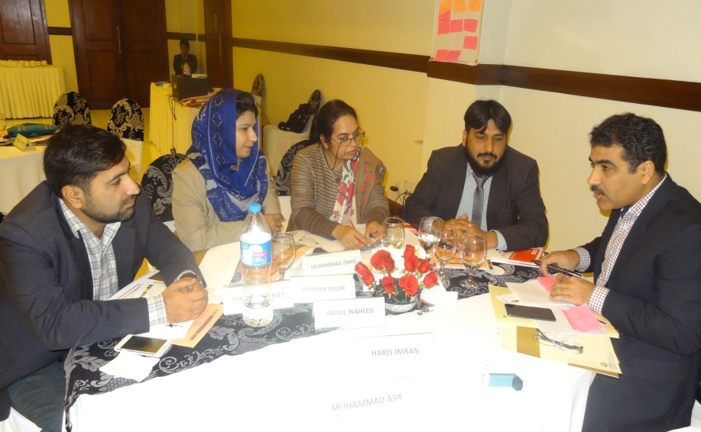
This session was conducted through an exercise; participants were divided into two groups the actors and the observers. The survivor stood in the center, the actors gathered in a circle while the observers in the outer circle. All the actors were assigned specific characters like mother, doctor, community worker, Psychologist, legal service provider and others. Each participant was asked to hold the thread around his finger when the survivor comes to him for assistance, but every time the thread had to be looped in the survivor’s finger as she was involved at every step. The trainer narrated the story of the survivor that how frequently she went to every service provider and tell her story repeatedly. After the story was finished, the trainer asked the observers to count the number of loops that shows the referral of the survivor to each service provider. Then she asked all of them to place the loops on the floor – thus making a web design, with survivor in the center as if stuck in the web.

Key Message

The key message of the exercise was to avoid the unnecessary interaction with irrelevant people and avoid psychological trauma by going again and again to different people and repeating the incidence. There should be a system in place where all department should work in coordination .The concerned people should be at one place to ensure prompt and effective response that respects the four guiding principles of the GBV survivor.

Module 3: HIV and STI Prevention: by Dr. Anjum
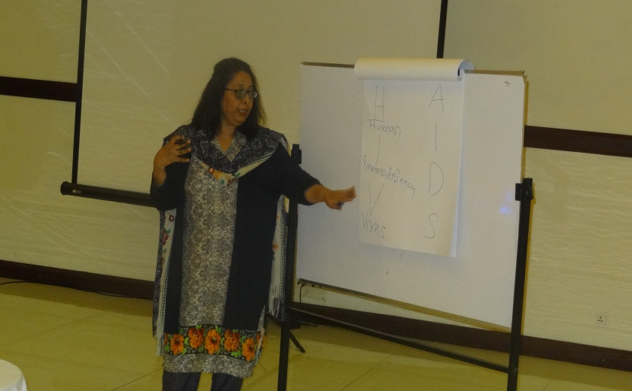
This module includes reducing HIV transmission and meeting STI needs In the acute Phase and expanding HIV and STI services as the situation allows. Key discussion points were rationale and safe blood transfusion, standard precautions, syndromic management of STIs availability of condoms and ARVs for continuing users and PMTCT. Importance of hand washing in crisis was discussed in detail followed by video screening for hand washing practices. It was further stressed that Planning for comprehensive HIV and STI services should start from the onset of crisis and implementation of comprehensive services should be started as the situation allows.

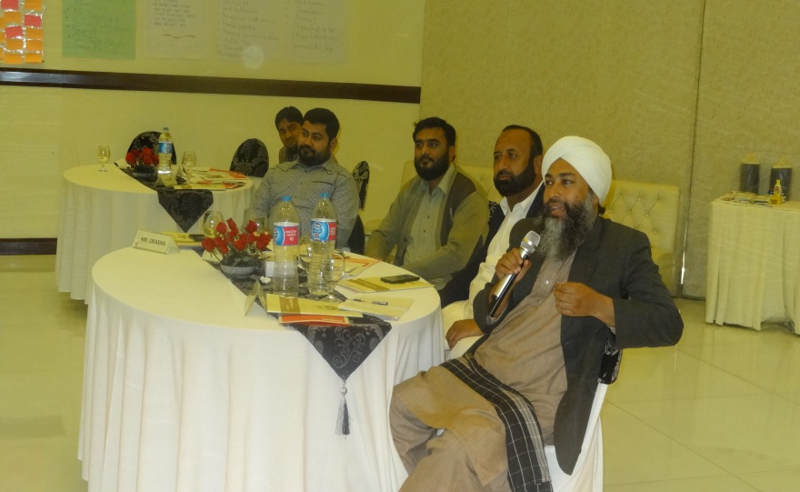
Comments by Participants:

The topic generated interest among the participants especially the linkage between SGBV, STIs and HIV. It was stressed that couple management is mandatory for treatment of STIs. Occupational exposure, sources of infection, hazard faced by the operation room staff were also discussed.

Module 4: Maternal and Newborn Health

The session was interactive as most of the participants had some experience working in MNCH. It was emphasized that preventing maternal and neonatal death must be a priority for the humanitarian settings. Major causes of maternal new born death worldwide were discussed with special focus on Adolescents, Three delays were discussed in length .there was discussion that followed on 3rd delay. Strategies like basic and comprehensive EMNOC and three delays model were also discussed. It was further discussed that comprehensive MNCH services should be implemented as soon as the situation allows.
Participants - Queries/comments:

Participants were of the view that antenatal is an important component to prevent maternal mortality and morbidity. After discussion they realized though antenatal is important but most of the deaths are occurring during natal period so during crisis priority should be on natal service .Three delays were discussed in detail taking it forward to four delays. Everyone participated and came up with suggestions on how to cope with delays.

DAY III

Recap for day II was conducted by two participants through quiz. Topics were HIV/STI and MNCH.

Module 5: Summary and Logistics: by Dr. Nadeem

In this module the Inter-Agency RH kits and logistics were discussed in detail by Dr. Nadeem with contents of different blocks meant for different types of services and population size.

Block 1- for Primary Health Care/health center level caters for 10,000 populations for a period of 3 months.
Block 2 – for Health centre level/referral level caters for 30,000 populations for 3 months’ time.

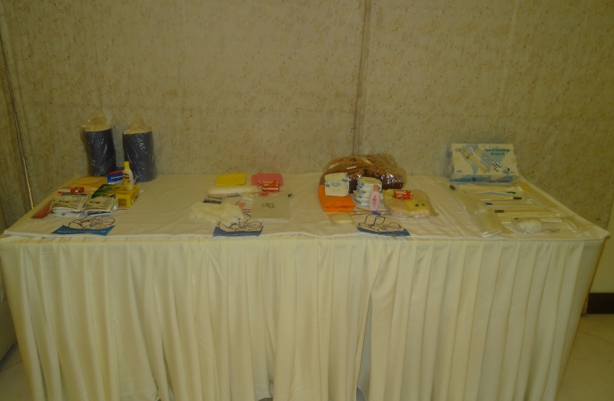
Block 3 – which is referral level block caters for 150,000 people for 3 months Participants asked about the mode of delivery of kits and other local logistic like custom clearance, observing the cold chain, in-country transport, coordination with local partners etc.
Cold chain for Oxytocin was discussed and participants shared that they never knew that cold chain is needed for oxytocin.
Comments by Participants: Most of the participants were not aware of the cold chain maintenance for Oxytocin. It was clarified that it is a misconception that it can be kept at room temperature. It loses its effectiveness if its cold chain is not maintained. The importance of proper calculation of the population was highlighted to avoid any delays in receiving the kit.

Participants Feedback
MISP was a new area of intervention for the training participants and this training was a novel opportunity of learning the unique SRH services as well as to provide optimum support for the pregnant women in times of natural or manmade disasters. The participants conveyed their profound gratitude to the R-FPAP and IPPF for organizing this informative workshop. They found workshop comprehensive and need of the day as Pakistan is a disaster prone country. Training was a huge success as it sought to address key gaps in their knowledge of issues. They were also very appreciative of the methods used by the facilitators. They believed that the participatory approaches used at all levels of the training had revitalized them and enhanced their willingness to acquire knowledge. The simulation exercise was appreciated as it gave them an oversight of the actual situation.

Closing Ceremony

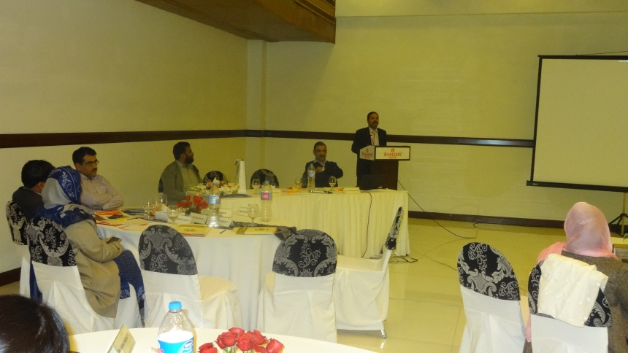
Mr. Barak Ullah Khan, Additional Deputy Commissioner General Multan was the chief guest at the closing ceremony. He admired the FPAP’s efforts on advocating SRH issues and he appreciated the efforts by SPRINT initiative by capacity building of the service providers.
He expressed his overwhelming satisfaction with the training. He pledged the continued support to FPAP for further MISP trainings and other capacity building initiatives. He expressed his gratitude and appreciation to the trainers for their exquisite skills and expertise to make the learning an enjoyable interactive activity.

Certificate Distribution:

Participants received training certificates from the Mr. Zeshan Nasir, District Population Welfare Officer, Multan.
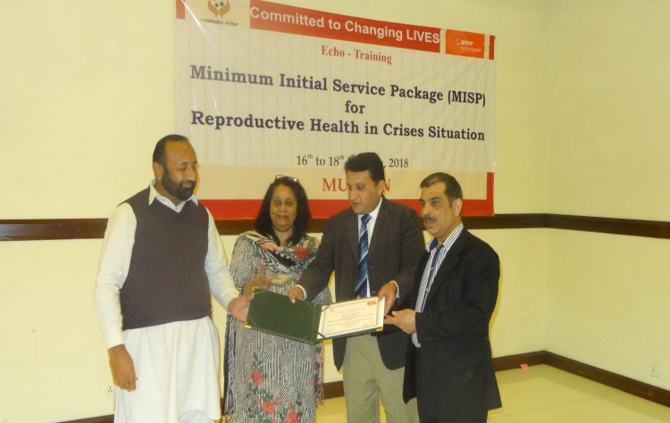
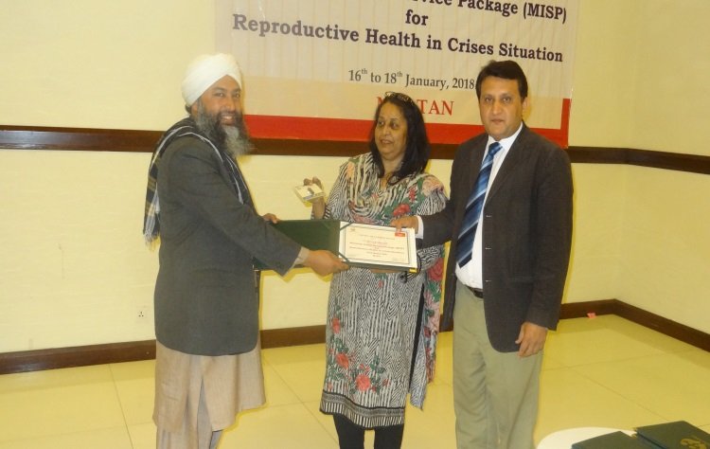
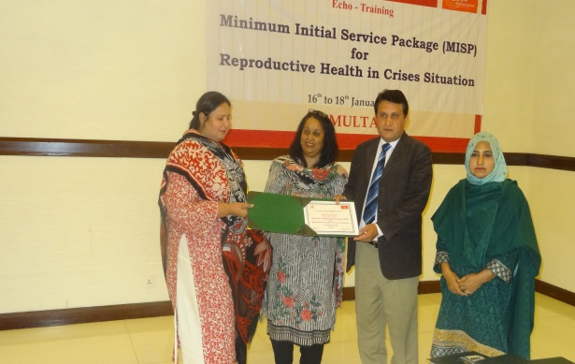
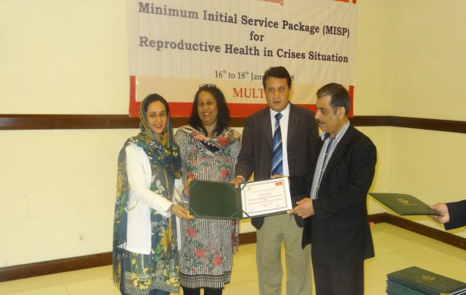

Comparison of Pre and post test result

The below graph indicates the percentage of correct answers during the pretest and posttest. The number of correct responses among the participants was an average of 40% pretest, with most of the participants having difficult and incorrect responses in question no:1, 3,5,7, which were clarified during the training, while in the post test 85% responses were correct.

Echo MISP Training

Multan

 | Item | Rating
 |  | 1  Poor | 1  Unsatisfactory | 2  Satisfactory | 3  Good | 4  Excellent | NA  Not applicable
1 | Accommodation |  |  |  |  | √
2 | Food |  |  |  | √
3 | Travel arrangements |  |  |  | √
4 | Meeting arrangements |  |  |  |  | √
5 | Administrative support |  |  |  |  | √
No | Item | Strongly disagree | Disagree | Not sure | Agree | Strongly agree
 | Achievement of training objectives |  |  |  | 10 | 17
 | Materials distributed |  |  |  | 13 | 14
 | Facilitation of training |  |  |  | 7 | 20
 | Timeframe allocated for the training programme |  |  |  | 12 | 15
 | Opportunities for sharing and participation |  |  |  | 10 | 17
 | Presentations were well organized |  |  |  | 07 | 20

