ACTIVITY REPORT

Implementing Partner: Rahnuma-FPAP
Title: Capacity Building Training of Peer Educators as Peer Counselors
Venue: Rahnuma Regional Hall_ District Karachi Date: 21 & 22 March 2018
No of Beneficiaries: 13

Introduction:
The 2 days Capacity Building Training of Peer Educators as Peer Counselors started with recitation of Holy Quran then welcome address and introduction of Rahnuma-FPAP was given by Imam Ali Detho (Regional Directors Sindh). During his speech he disseminated importance of SRH education and knowledge for young people for positive change in community. Shahnaz Faeth briefed about GUSO project’s objectives and importance of youth as peer Counselor.
. 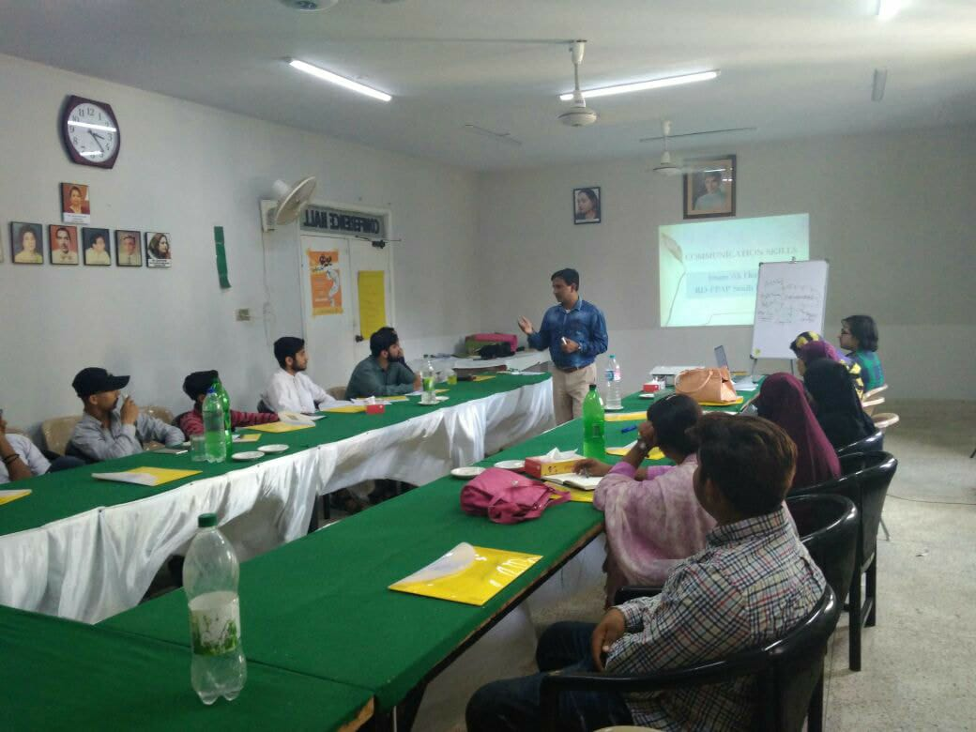
The topic with the workshop Agenda was covered as followed

Understanding Gender and gender role
With the help of brain storming, group work and PowerPoint presentation, Understanding & clarity about Gender and gender roles were disseminated. Perception about gender and sex were differentiated by counseling officer. Gender roles were unwrapped through group activity. in the end they reply that before taking this session they have just know that gender means male female but now we have clear concept that gender are roles and responsibilities assigned by society and can be changeable and we must counsel our peer to change their perception about gender.

What is counseling and who is good counselor
Rubina Hafeez Counseling officer facilitated this session; she used different interactive techniques and PowerPoint presentations for disseminating counseling skills. She acknowledged the power young people how can they help community youth on their SRH issues as a peer educator regarding sexual reproductive health issues. With the help of power point facilitators disseminated the qualities of good counselor. All participants took great interest in the session and shred the qualities of a good counselors as,
- Good listener
- Genuineness
- Non Judgmental
- Welcoming
- Empathetic
- Maintain confidentiality

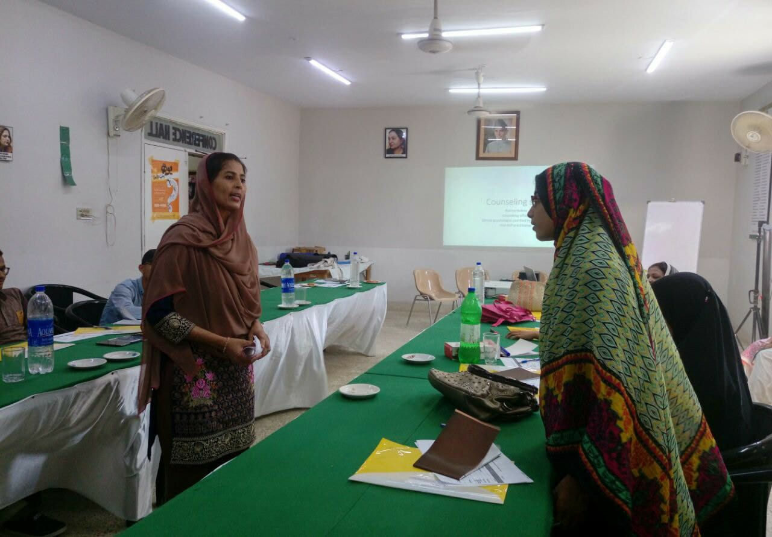

What is counseling and what is not counseling.
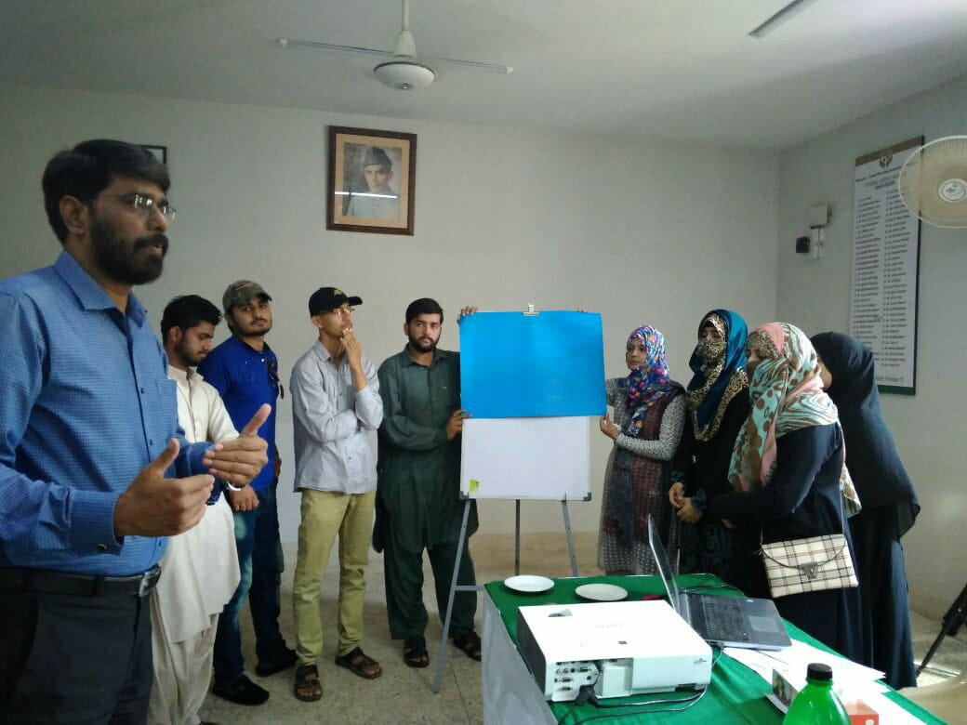

This session was taken by Shoaib Ahmed in which he disseminated how counseling process develops decision making in peers .he also differentiated counseling and advice or suggestion. With the role play effective counseling skills and rapport building with client were also strengthen in all peer counselors.

Youth issues during developmental stages
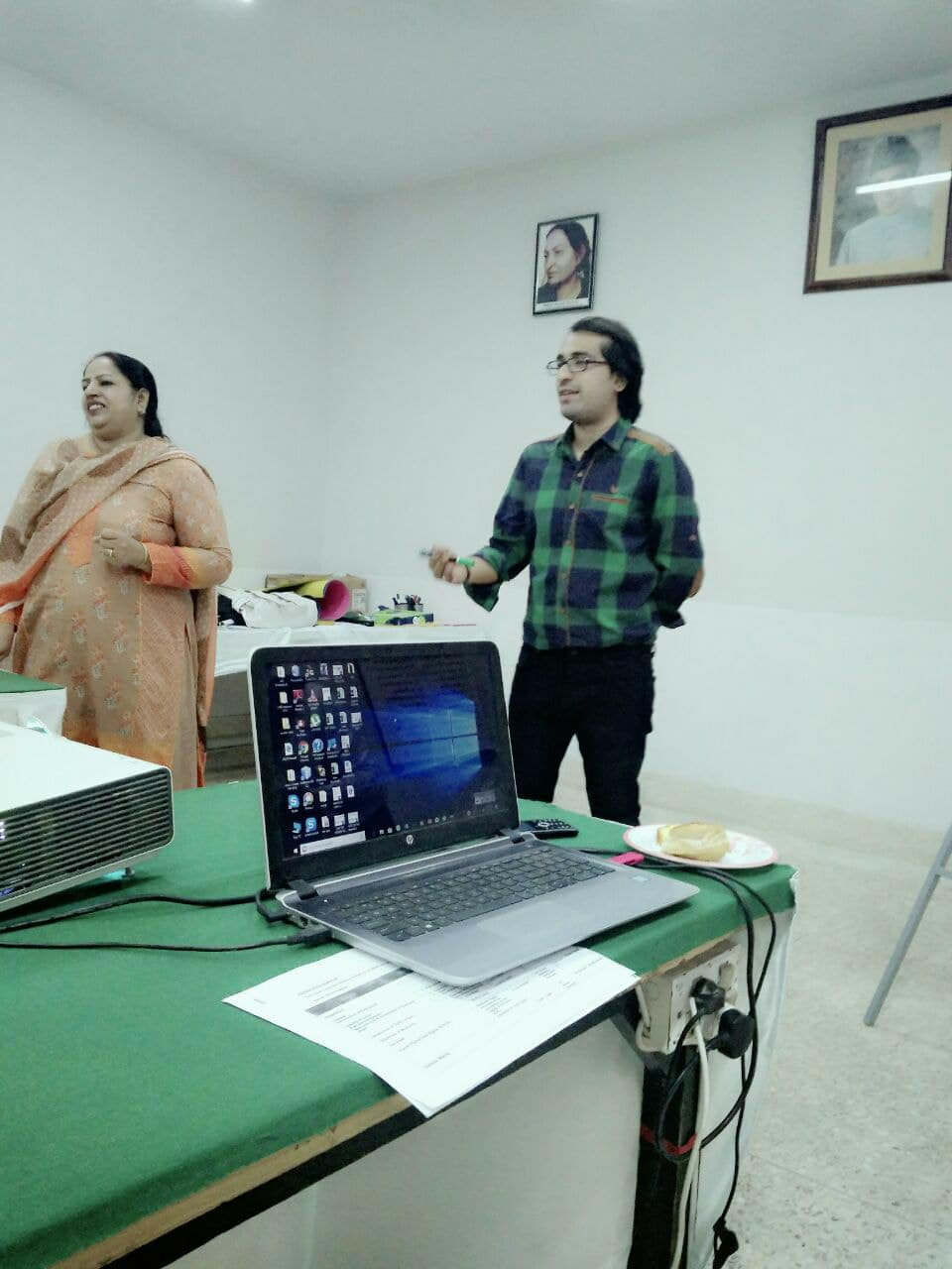

This session was facilitated by Rubina Hafeez (counseling officer), she revealed the scenario of youth in Pakistan and their SRH issues during puberty stage. She also shared that in Pakistan has very few limited youth friendly service counseling delivery points, which is not enough for more than 60% population of youth so it is our duty as a counselor to provide best counseling to their peers. With the help of group activity, she brought following youth issues as under.

Anxiety about acne and pimples
Shame and worries about first menses
Shame and anxiousness abut nocturnal ejaculation
Guilt ,shame and low self esteem related to masturbation
Irritability and outburst on minor issues
Communication problem
Anxious about
Loneliness
Depression
phobias

SOLER, as no verbal listening skills in counseling

This session was facilitated by Rubina Hafeez Counseling officer Youth she said active listening is not just about taking information in and processing it. It is also about our physical demeanors she disseminated five key components of active listening/nonverbal, known by the SOLER:
S: Sit straight (this is important in conveying the message that ‘I am here with you.’)
O:Open posture (indicating openness to listening to anything the speaker chooses to share)
L:ean forward (indicating an interest in the speakers words)
E:Eye contact (another way of expressing interest and reassurance)
R: Relax (a relaxed posture puts the speaker at ease).
In her summarization remarks ,said verbal and non verbal communication are very effective for better outcomes in counseling

Referral Mechanism in counseling

Shoaib Ahmed developed importance of Referrals mechanism, in general describe the processes of how a youth gets in touch with an individual professional or institution about their SRH & SGBV related issue and how professionals and institutions communicate and work together to provide her with comprehensive support to youth. Partners in a referral network usually include different medical service delivery points, government departments, legal support forum women’s organizations, community organizations, medical institutions and others. Women who have experienced different kind of violence/GBV have multiple and complex needs. This includes medical care, safe accommodation, psychosocial counseling, police protection and/or legal advice. He further said that Therefore, an effective response to GBV requires a comprehensive set of services. Since it is virtually impossible for a single organization to provide all services in the required quality and specialization, a multi-sect oral response that coordinates the services by all relevant service providers helps to ensure the availability of comprehensive support for survivors of GBV. He also addressed that youth help line # could be used for counseling\g and referral mechanism

In the end Syed Ziyad Furqan also said all LSBE components are best tool to change unsafe behavior to safe behavior

feedback session by Regional Director

Mr Imam Ali Detho (RD Sindh) asked from participants about their learning level, in reply youth said such kind of interactive and participatory training never attended before it will helpful in their profession too, and we think it will be very fruitful for our youth to increase knowledge level it enhance our perception positively, and thanks Rahnuma for awareness on this topic.
Out comes:
- After completion of workshop 13 peer counselor were trained instead of 6
- Youth issues were revealed on which youth need thirst to counsel
- Accebilities and friendly counseling services is limited so peer can be utilized as peer counselors
- Young girls and women face more violence rather than man
- SGBV effect personality of a women
- Counseling can change unsafe behavior to safe behavior

Assigning Tasks :
Syed Ziyad Furqan program officer described the all participants to arrange 3 sessions by each peer counselor to be completed before Dec 18and asked share tentative work plan before Dec. 2018

Output:
 | Age 10-14 |  | Age 15-19 |  | Age 20-24 |  | Age 10-24* |  | Total number
Target group | F | M | F | M | F | M | F | M
 | ---- | --- | 2 | 5 | 3 | 3 | 5 | 8 | 13

Comments & Recommendations:

Training was very interactive, helpful, informative, knowledgeable, useful, interesting, encourage able and inspiring for all participants. Food and other arrangement was good

- Psycho social support programs must increase in community
- Counseling desk should arrange by academic institute for their students
- YHL # advertized on television regular basis
- Rahnuma should arrange counseling desk in Govt Schools and colleges by trained psychologist and peer counselors.

Name: Signature & Date:

Name and Signature with Date of Project Coordinator: _____________

